Ild spark vm into oracle virtual box

Imported the acad

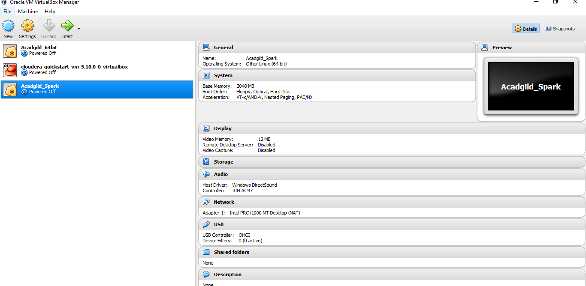

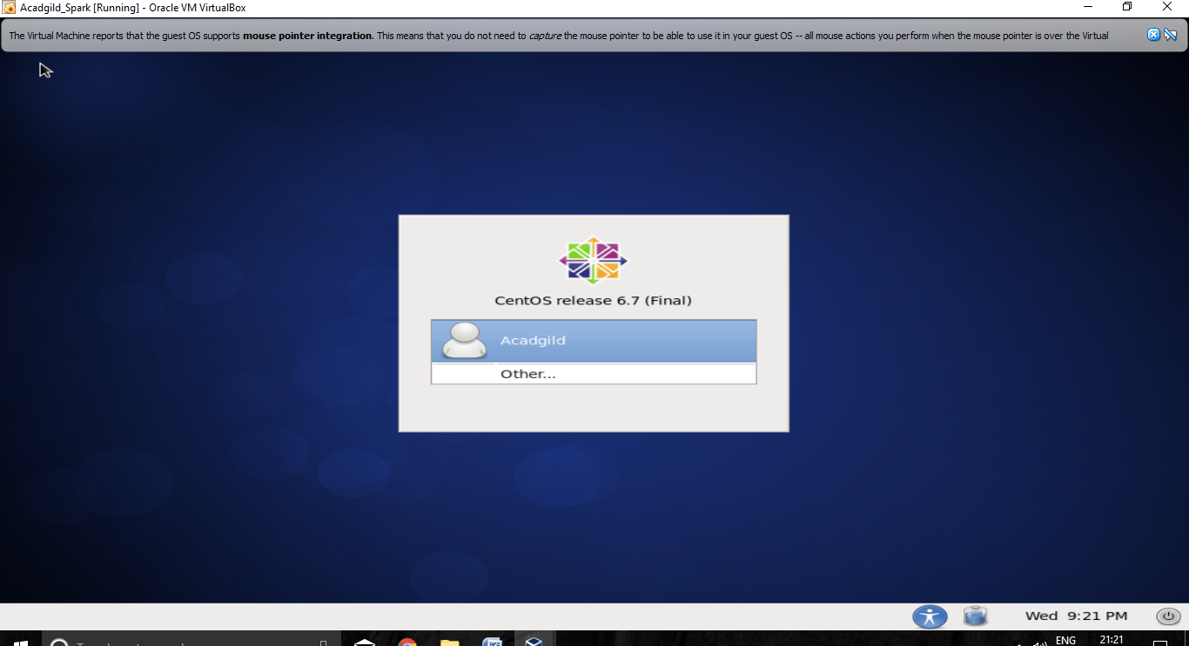

**Starting Spark daemons Master,Workers**

Move into the sbin folder of spark installed directory(Here spark is installed in /usr/local/spark/ directory.)

**Starting Master:**

**Command: ./ start-master.sh**

**Starting Slaves:**

**Command: ./start-slaves.sh**

